1. Using Insert Function, give examples of any function available in the

different dropdowns present in the function library. For example

AutoSum, Recently Used, Text, Date & Time, etc.

Use the**Insert Function** dialog box to help you insert the correct formula and arguments for your needs. (To view the **Insert Function** dialog box, click Insert function

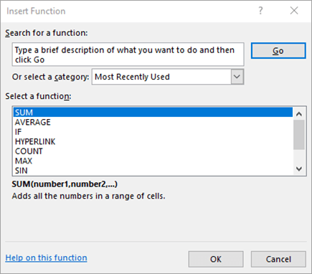

**Search for a function**

Type a brief description of what you want a function to do, and then choose **Go**. A list of functions likely to fit your needs and based on your description will display in the Select a function box.

**Or select a category**

From the drop-down list, do one of the following:

* Select **Most Recently Used**. Functions you have inserted in the recent past will display in alphabetical order in the **Select a function** box.
* Select a function category. Functions in that category will display in alphabetical order in the **Select a function** box.
* Select **All**. Every function will display in alphabetical order in the **Select a function** box.

**Select a function**

Do one of the following:

* Click a function name to see the function syntax and a brief description immediately below the **Select a function** box.
* Double-click a function name to display the function and its arguments in the **Function Arguments** wizard, which helps you add correct arguments.

2. What are the different ways you can select columns and rows?

* Select the letter at the top to select the entire column. Or click on any cell in the column and then press Ctrl + Space.
* Select the row number to select the entire row. Or click on any cell in the row and then press Shift + Space.
* To select non-adjacent rows or columns, hold Ctrl and select the row or column numbers.

3. What is AutoFit and why do we use it?

Excel's AutoFit feature is **designed to automatically resize cells in a worksheet to accommodate different sized data without having to manually change the column width and row height**. AutoFit Column Width - changes the column width to hold the largest value in the column.

4. How can you insert new rows and columns into the existing table?

**Add a row or column**

1. Click where you want in your table to add a row or column and then click the Layout tab (this is the tab next to the Table Design tab on the ribbon).
2. To add rows, click Insert Above or Insert Below and to add columns, click Insert Left or Insert Right

5. How do you hide and unhide columns in excel?

On the Home tab, in the Cells group, click Format. Do one of the following: **Under Visibility, click Hide & Unhide, and then click Unhide Rows or Unhide Columns**.

6.Create an appropriate table within the worksheet and use different

functions available in the AutoSum command.

If you need to sum a column or row of numbers, let Excel do the math for you. Select a cell next to the numbers you want to sum, click **AutoSum** on the **Home** tab, press **Enter**, and you’re done.

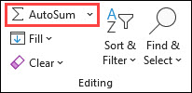

When you click **AutoSum**, Excel automatically enters a formula (that uses the [SUM function](https://support.microsoft.com/en-us/office/sum-function-043e1c7d-7726-4e80-8f32-07b23e057f89)) to sum the numbers.

Here’s an example. To add the January numbers in this Entertainment budget, select cell B7, the cell immediately below the column of numbers. Then click **AutoSum**. A formula appears in cell B7, and Excel highlights the cells you’re totaling.

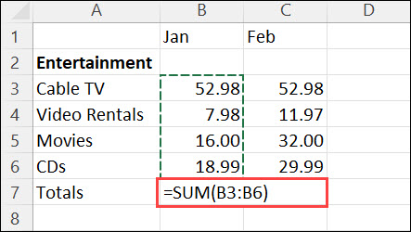

Press Enter to display the result (95.94) in cell B7. You can also see the formula in the formula bar at the top of the Excel window.

